Warning – Shift Out of Neutral – PHEV/FHEV - CGEA1.3

Functional Description

The purpose of the Shift out of Neutral warning contained within this STSS is to inform the driver that the transmission should be shifted out of Neutral to avoid high voltage battery drain. This feature is applicable on Power Split PHEV and FHEV vehicles.

Certain customers have a tendency to put their vehicle in a neutral when standing at a red light, or at gas stations for an extended period. The way the power-split vehicle works in neutral gear is that it turns off the engine preventing the HV battery of being charged. When the customer has their AC on and shifts the gear into Neutral, the AC compressor, which runs off of high voltage, risks drainage of the HV battery beyond a threshold. The vehicle shuts the AC compressor off, which results in no cooling in the cabin to protect the battery from failures.

The control module shall be responsible for all vehicle level configurations. The IPC shall be responsible for activating the warning message upon receipt of the correct state of the input signal.

The Shift to Neutral warning function correlates the ShifOutNtrlMsgTxt_D_Rq signal from the Secondary OBD Control Module “C” (SOBDMC) and Operational_Mode to either activate or deactivate the warning message on the cluster display.

Interfaces

Interface Context Diagram (I/O Block Diagram)
Figure 1: Shift Out of Neutral Warning Context Diagram
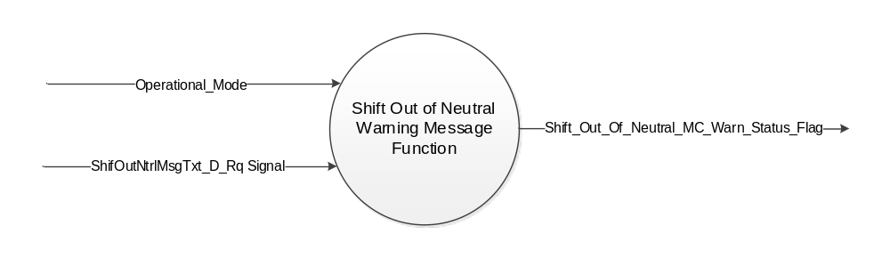

Inputs

      - INTERNAL:
            - Operational_Mode

      - MUX signal on CAN
- ShifOutNtrlMsgTxt_D_Rq Signal
Signal Name | Size  (bits) | Detail | Units | State Encoded | Min. | Max.
ShifOutNtrlMsgTxt_D_Rq | 3 |  | SED |  | 0 (0x0) | 7 (0x7)
 |  | No Message |  | 0x0
 |  | Message1 |  | 0x1
 |  | Message2 |  | 0x2
 |  | Message3 |  | 0x3
 |  | Message4 |  | 0x4
 |  | Message5 |  | 0x5
 |  | Message6 |  | 0x6
 |  | Message7 |  | 0x7

Outputs
      - Shift_Out_Of_Neutral_MC_Warn_Status_Flag, which is used to control the state of the warning message.

Function/Performance

Operational Modes

Mode | Operational Mode
Sleep Mode | Shift Out of Neutral Warning Inactive
Limited Mode | Shift Out of Neutral Warning Inactive
Normal Mode | Shift Out of Neutral Warning Active / Inactive
Crank Mode | Shift Out of Neutral Warning Active / Inactive

Voltage Levels

Refer to the Cluster Features table located in the Operational Modes and Voltage Range Strategies section in this SPSS.

Human-Machine Interface

Visual

Indicator Graphics / Display Format

Message Center Text Warning Messages as defined in section Table 1.2 of this document.

Indicator Color Coordinates

Reference section COLOR & ILLUMINATION REQUIREMENTS (GRAPHICS).

Audio

None

Switch Control Logic

None.

System Accuracy

Within 100 msec of receiving a message that results in a change of state the cluster will update the output flag to the proper state.

Operation: Performance and Functional

Subsystem Algorithm Flowchart / State Diagram

- State Matrix for Shift Out of Neutral MC Warning Status Flag
Operational_  Mode | ShifOutNtrlMsgTxt_D_Rq Signal | Shift_Out_Of_Neutral_  MC_Warn_Status_Flag
Normal or Crank | Message1 (0x1) | Active
Normal or Crank | Declared Missing as per 1.4.1 | Inactive
All Other Cases |  | Inactive

- Pedestrian Sounder Flag MC Status Flag to MC Message IDs
MC Status Flag | Mc Warning Message ID
Shift_Out_Of_Neutral_MC_Warn_Status_Flag | W3200

Operation Description (supports algorithm flowchart /state diagram)

- For definition of how the Message Center arbitrates and displays Active warnings, see the Warning / Alert Display Logic Diagram, located in the Message Center – X Display with W Button Interface section of this SPSS (where X and W are appropriate values in this document).

Function Safety Classification (EMC)

Class B

Memory Storage
Parameter Name | Description | Value at  Battery Connect | Value at  Module Wake-up
Shift_Out_Of_Neutral_MC_Warn_Status_Flag | Output display status flag used to activate warning. | Inactive | Inactive
ShifOutNtrlMsgTxt_D_Rq Signal | CAN signal sent from the SOBDMC module. | No Message  (0x0) | No Message  (0x0)
Operational_Mode | 4 state indicator for cluster operational mode. | Limited | Limited, Normal or Crank

Prove Out

None.

Reconfigurable Telltale

None

Message Center Message

See Section 1.3.5.1 for state tables and Table 1.2 for Warning Message ID.

Error Handling

Missing Message Strategy

None

Diagnostics

Self Test

None.

Engineering Test Mode

None.

Part II Performance

DID $DExx

None

Supported Diagnostic Trouble Codes (DTCs)

None

Reference Specifications

IS-0001 WARNINGS/INDICATORS/DISPLAYS PROVEOUT
IS-0046 INSTRUMENTATION MATERIAL RESISTANCE TO CLEANING
IS-0052 OPERATING VOLTAGES - FUNCTIONAL/PERFORMANCE
IS-0069 FUNCTIONAL IMPORTANCE CLASS
IS-0324 WINDSHIELD & OTHER REFLECTIONS
IS-0327 WARNING INDICATOR EVALUATION
IS-0379 NORTH AMERICAN WARNINGS AND INDICATORS STRATEGY

IL-0021 CRAFTSMANSHIP - DISPLAYS
IL-0023 CLARITY/LEGIBILITY/READABILITY
IL-0025 INTERIOR ILLUMINATION INTENSITY
IL-0027 VISUAL CONTRAST
IL-0043 OPERATIONAL ENVIRONMENT FUNCTIONALITY
IL-0045 COLOR
IL-0048 ILLUMINATION ACCEPTABILITY

03-0661 PLACEMENT: CONTROL AND DISPLAY LOCATIONS
03-0662 PLACEMENT: LOGICAL GROUPING FUNCTION AND USAGE
03-0664 PLACEMENT: DOWN VISION TO COMPONENTS WITH HIGH VISUAL DEMAND
03-0665 PLACEMENT: EXPECTED LOCATIONS OF CONTROLS AND DISPLAYS VDS
03-0670 INTERIOR VISIBILITY
03-0671 INTERIOR VISIBILITY: REFLECTIONS FROM COMPONENTS & SURFACES
03-0672 INTERIOR VISIBILITY: REFLECTIONS IN DISPLAYS
03-0673 INTERIOR VISIBILITY: VISUAL OBSCURATIONS
03-0674 INTERIOR VISIBILITY: ILLUMINATION CONTROLS / DISPLAYS
03-0675 INTERIOR VISIBILITY: VEILING GLARE
03-0677 INTERIOR VISIBILITY: SUNLIGHT WASHOUT
03-0681 IDENTIFICATION: CHARACTER AND SYMBOL SIZE
03-0682 IDENTIFICATION: LEGIBILITY
03-0685 IDENTIFICATION: SYMBOLS, ABBREV FOR CONTROL
03-0721 LOGIC OF OPERATION: OPERATIONAL STEREOTYPES
03-0722 LOGIC OF OPERATION: INTERPRETATION
03-0723 LOGIC OF OPERATION: USE OF SYSTEMS WITH VISUAL DISPLAYS

Revision History

STSS Module Revision History

Revision Level | Name | Change Description | Date
1.0 | V. Patel | Initial release.  (Feature owner: Charbel Bouery)  DI CC approval: 8/17/2017 | 9/12/2017

